Project Plan

Synthesis Assignment

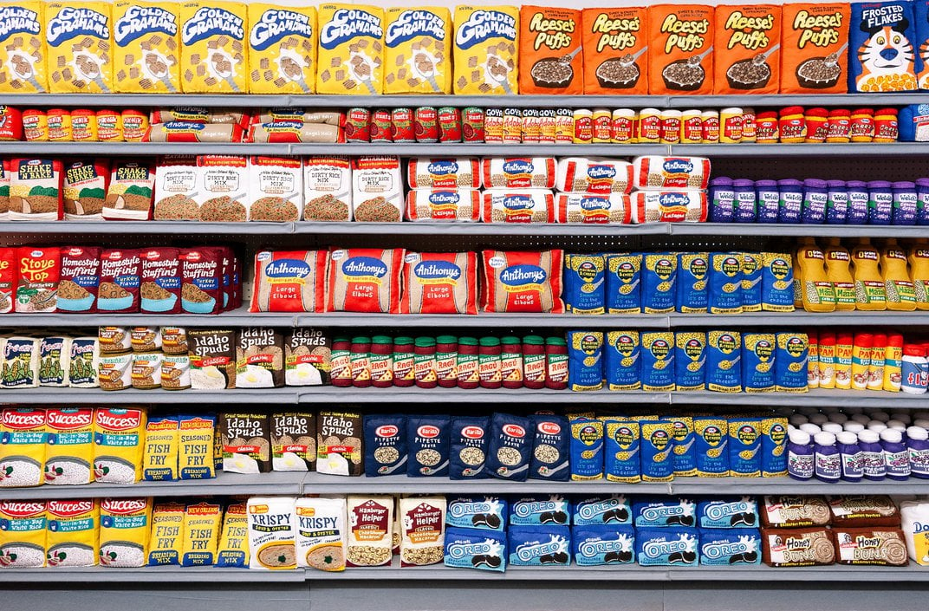Stoyan Grozdev

Content

Table of content

1. Client Description…………………………………………….

2. Team introduction…………………………………………….

3. Current situation……………………………………………….

4. Problem statement……………………………………………

5. Project goal…………………………………………………………

6. Deliverables and non-deliverables…………….

7. Project constraints……………………………………………

8. Planning……………………………………………………………….

Client description

The company RobertHeijn B.V. wants a software solution to allow customers to shop online. The main user is the customer which orders products online.

Team Introduction

The team consists of one person, Stoyan Vladimirov Grozdev who is going to develop the software solution. Stoyan has experience in C#, MySql, css, html , ASP.NET. He has enough knowledge to develop the solution. Contact: [s.grozdev@student.fontys.nl](mailto:s.grozdev@student.fontys.nl).

Current situation

At the moment RobertHeijn B.V. doesn’t have the possibility to allow customers to select a product and make an order and staff don’t have the possibility to add, remove or update products for sale and make promotions.

Problem statement

The application is separated in two major steps. The first step will implement all the core requirements and the second step will create the functions as understood and agreed upon by the client.

Project goal

The project goal is to develop a software solution that will allow customers to log in and out, see an overview of their orders, make an order, use bonus points and allow for company staff to make new products, update products and ect.

Deliverables and non-deliverables

The deliverables include Project Plan, URS, Test plan, and Test Report, the software, unit testing, database. All core requirements will be delivered and one major and one minor requirement and if possible more than one will be delivered.

Project constraints

The technologies that are going to be used are C#, Windows forms, HTML, CSS, MySql, ASP.Net Core. The submit date for the project is 23rd of December of 2022. The development time is small so there is little space for error.

Phase planning : week 11

Phase 1:

Activity: Documentation

* Activity 1.1a:
  + Analyzing the synthesis Document
  + Time: 40 minutes
* Activity 1.2a:
  + Creating the Project plan
  + Time: 50 minutes
* Activity 1.3a:
  + Creating the URS document
  + Time: 2 hours
* Activity 1.4a:
  + Making the UML diagram
  + Time:2 hours
* Deliverables:
  + Project plan
  + URS document
  + UML diagram

Phase 2: week 12-13

Activity: Implementing core requirements

* Activity 2.1a:
  + Implement all classes
  + Time: 3 hours
* Activity 2.2a:
  + Creating the login and registration for the webpage
  + Time: 2 hours
* Activity 2.3a:
  + Creating the windows forms that allows staff to CRUD groceries
  + Time: 6 hours
* Activity 2.4a:
  + Creating the home menu where customers can select which items they want to order
  + Time: 5 hours
* Activity 2.5a:
  + Creating a page from where customers can view previous orders
  + Time: 6 hours
* Activity 2.6a:
  + Bug fixes
  + Time: 1 hour
* Deliverables:
  + Desktop application
  + Website

Phase 3: week 14

Activity: Implementing major requirements

* Activity 3.1a:
  + Implementing Bonus cards and collecting points
  + Time: 2 hours
* Activity 3.2a:
  + Bug fixes and punishment
  + Time: 2 hours
* Deliverables:
  + Updated software with major requirements

Phase 4: week 15

Activity: Implementing minor requirements

* Activity 4.1a:
  + Implementing the possibility to change the status of the order
  + Time: 2 hours
* Activity 4.2a:
  + Implementing the possibility of customers to return items
  + Time: 2 hours
* Activity 4.3a:
  + Implementing the possibility of customers to spend bonus points
  + Time: 2 hours
* Activity 4.3a:
  + Bug fixes
  + Time: 2 hours

Phase 5: week 16

Activity: Unit test

* Activity 5.1a:
  + Making the unit test
  + Time: 2 hours
* Activity 5.2a:
  + Creating Test plan
  + Time: 2 hours
* Activity 5.3a:
  + Creating Test report
  + Time: 2 hours
* Activity 5.4a:
  + Get feedback
  + Time: 1 hours
* Deliverables:
  + Test plan
  + Test report
  + Unit testing

Phase 6: week 16

Activity: Bug fixes and improving Code quality

* Activity 6.1a:
  + Going through the whole code for bugs
  + Time: 1 hour and 30 minutes
* Activity 6.2a:
  + Fixing typos, checking for code optimization
  + Time: 2 hours
* Deliverables:
  + Windows forms
  + Web page